FOR IMMEDIATE RELEASE

One Truckee River will present at City of Reno Public Meetings to Discuss the Truckee River Restroom Project

Contact: Iris Jehle-Peppard, Executive Director, iris@onetruckeeriver.org, (775) 450-5489

FOR IMMEDIATE RELEASE

Jan. 7, 2022—RENO, Nev— One Truckee River (OTR) will present at City of Reno public meetings to discuss the Truckee River Restroom Project. As part of the OTR Management Plan, Phase I. The Project is a collaborative effort to protect the Truckee River’s water quality from human impacts and meet the growing recreational need for public restrooms along the river.

In 2020, the Project’s first public restroom was installed along the river at Brodhead Memorial Park. Now, One Truckee River is seeking public input to prioritize future locations, including but not limited to, Bicentennial Park, Mayberry Park, and Veterans Parkway. The public is invited to participate in the meetings listed below. For more information about the Project and to take a short survey about the effort, visit onetruckeeriver.org.

WARD 1: Tuesday, January 11th, 5:30 - 7:30 pm virtual at Reno.gov/meetings
WARD 5: Tuesday, January 11th, 5:30 - 7:30 pm virtual at Reno.gov/meetings
RECREATION AND PARK COMMISSION: Tuesday, January 18th, 5:30 to 7 pm virtual at Reno.gov/meetings
RENO CITY COUNCIL MEETING: Wednesday, February 9th, 10 am at the Reno City Hall Council Chambers, One E. 1st Street, Reno. General presentation.
RENO CITY COUNCIL MEETING: Wednesday, February 23rd, 10 am at the Reno City Hall Council Chambers, One E. 1st Street, Reno. Inter-local agreement for loo installation at John Champion Park.

"Public restrooms are basic building blocks of complete, functioning public parks and along the Truckee River they are crucial to have to protect water quality and enhance recreation experiences” said Iris Jehle-Peppard, Executive Director of One Truckee River.

One Truckee River (OTR) is a collaboration of public and private partners that works to ensure a healthy, thriving, sustainable river connected to the hearts and minds of its community. For more info about One Truckee River and the OTR Management Plan, visit onetruckeeriver.org.

###

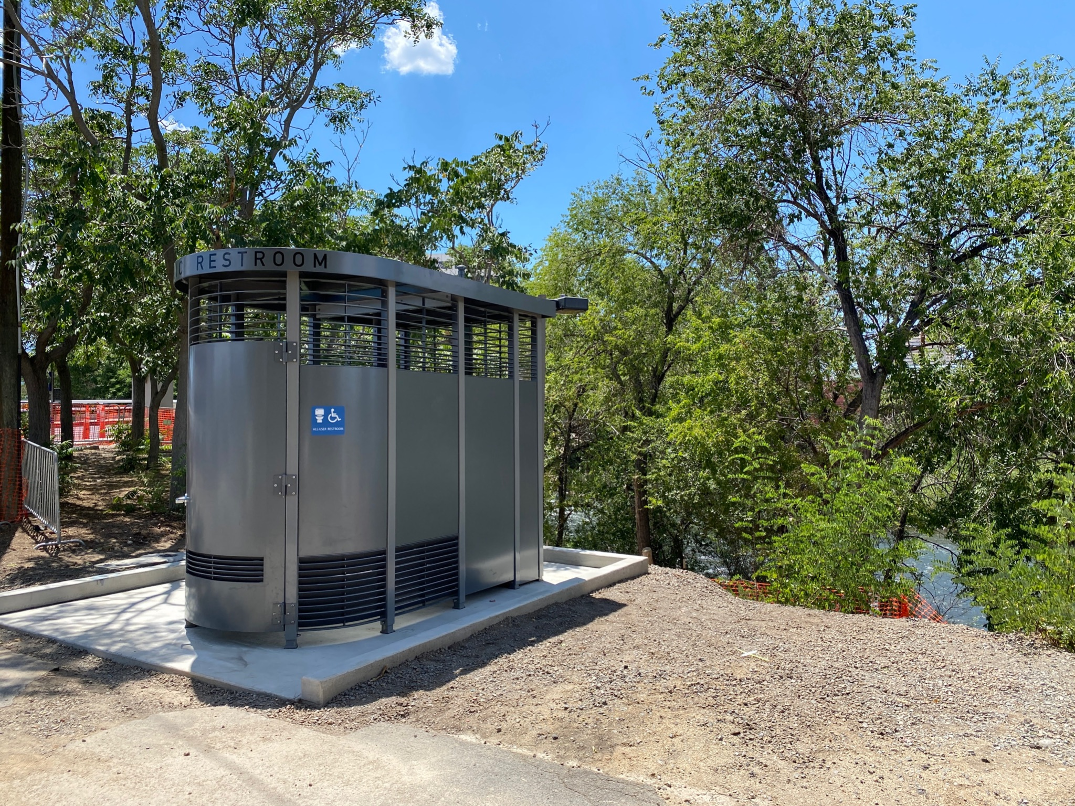
Truckee River Restroom at Broadhead Memorial Park.

